# ABSTRACT

# INTRODUCTION

## PURPOSE

Our project Truth, is a news verification system. It focuses on the integrity of the voting of news articles with Blockchain technology. Verified news articles are added to a database and then displayed under verified articles, while false articles are discarded. A user builds credibility by verifying articles.

## SCOPE

Truth consist of a web service, a mobile application and a website working in unison. The mobile application and website communicates with the web service to access data on the database and the blockchain. The mobile application only display the verified articles. The website registers new clients, displays articles and gives the users the opportunity to verify the article by giving it a rating out of four. The admin of the page are the only users who can add new articles. All of the components are hosted on an EC2 instance. Our project is designed for an audience with little technical knowledge.

# BACKGROUND

“We define “fake news” to be news articles that are intentionally and verifiably false, and could mislead readers.” (Allcott and Gentzkow, 2017:4)

# SOFTWARE SPECIFICATION AND IMPLEMENTATION

## MOBILE APPLICATION

Our mobile application is written in Java through Android Studio. The application does not allow registration or login. These features are available on the website only. The application does however display verified articles. The mobile app lets the user briefly see the top verified stories in summary form of the article. The app communicates to the database to get the articles from the database.

## 4.2 WEBSITE

The website is written in HTML and makes use of JavaScript to call php functions and so on, and CSS. The website has two sections: the general users’ section and the admin section. The general user can read and then validate the articles by placing a vote with values ranging from 0(Absolutely False) to 4(Very True) on the desired article. The admin is the only user with the ability to add new articles. The articles are added to the database in a certain format such as Author, Title, Description and Article. The votes associated with the article, are added to the blockchain so the votes aren’t tampered or changed.

## WEBSERVICE

The webservice is written in PHP and makes use of JSON output for certain values obtained from the (MySQL)database. The webservice handles all communication (requests and posts), from:

* The website to the database,
* The website to the blockchain and
* The mobile application to the database.

## CLOUD

Our project is on Amazon’s Webservice (AWS) on an EC2 instance. The EC2 hosts an Ubuntu server. All of our files are added to the EC2’s localhost directory(/var/www/html/) to load the files from a remote computer via a web browser. Our main blockchain chain is also hosted on the EC2. The instance is loaded with a LAMP stack and multichain software. There are special security groups formed for this instance as well as Elastic IP’s.

## 4.3 BLOCKCHAIN

We used Multichain as our Blockchain creator. Multichain is a very flexible tool, allowing developers to create their own chain with streams and assets. Multichain also offers the feature to mine and customize the chain’s parameters to suit your needs.

# TECHNICAL DETAILS

## TECHNOLOGIES USED

We have used AWS’s EC2, PHP, HTML, Javascript, Java, CSS and Multichain, MySQL(mysqli), Putty, WinSCP. The group had prior experience of HTML and Java but had to learn the rest of the languages.

## PROBLEMS FACED

The multichain software has little online support and tutorials, leaving us with many problems and questions that we had to answer ourselves. This took a lot of our time. Another time consuming task was the fact that we had to learn a lot of new programming languages to create our project. We also struggled with the connection of the chains through the AWS instance that we have created. Another problem was the creation of the web service, it was difficult and all the online tutorials was rather complicated to understand. Sometimes the group experienced problems with communication, and struggled to reach each other for a progress report.

# LESSONS LEARNED

## IMPORTANCE OF EFFECTIVE TIME MANAGEMENT

During the project, we constantly struggled with time management. The time assigned to each task was not enough, so the phases overlapped each other.

## TEAM WORK

When the whole team is not working effectively, the phases are not met in time. The project is a project with a very steep learning curve, making it impossible for only one person. The work has to be divided in manageable pieces for each member. The work breakdown structure has changed through the project and each member adjusted quickly with the new sections assigned to them. The team spirit was positive for most of the project, creating a peaceful, respectful environment for all.

## FAILING FAST

During the project we continuously struggled to fail fast, in other words we kept on struggling with the same problems. This will have to improve to be able to complete future projects more successfully.

# BUSINESS CASE

## EXECUTIVE SUMMARY

**Subject**

We live in a day and age of almost unlimited access to information thanks to the internet. The internet has enabled us to distribute content and communicate across continents in an instant. We all enjoy the ease of access to information, whether it be consuming or creating information for others to consume and discuss, but we never stop to think about the validity of the information we consume. This needs to change, we need to validate and add credibility to news sources in an attempt to stop the distribution of misinformation.

**Scope**

Our scope is small and simple. Create an environment where your readers have the ability to vote on the credibility of your articles that you publish. If an article fails validation it is removed from the “truth” feed as we call it. Only valid articles remain in this feed. The community can therefore be assured that the content in this feed is accurate and validated by the same people that form part of the readers online community.

**Method of analysis**

There are lots of people in the world that are motivated to write fake news articles for a multitude of reasons. They either profit from the act whether it be via advertisement or they get paid for the amount of articles they write regardless of the content. Others are motivated to mislead the public to further their own agenda.

Our business is to create an environment where fake news / hoax writers can be exposed, not to enforce justice on these people but to allow the public access to accurate information.

**Key results and findings**. OBJECTIVES OVERVIEW

Our first and most important objective is to help create an online environment where news readers can easily establish the credibility of what they are reading. This has become crucial in today’s online environment where fake news has risen as a hot topic as far as social issues regarding the internet is concerned. This is largely because of how social media has changed the way readers gather news these days. Alarmingly, Allcott and Gentzkow (2017:2) noted that of news readers in the United States, 62 percent used social media to get their news, Facebook users were the main culprits for the sharing of fake news stories and a large number of readers reported that they believed fake news stories.

We believe that increasingly, the most reliable news sources will become the most successful. In a business sense, our objectives thus include the desire for news outlets to accept that the verification of their articles will have an effect on the number of readers they have. With the use of misleading titles, more commonly knowns a “clickbait” also on the rise, we aim to reduce the number of clicks any articles that use fake content or misleading titles, to the point where publishing such articles would no longer be worth the time or effort.

In the same way blockchain technology has recently been used to add transparency to the diamond trade, where the trade of blood diamonds polluted the market, we would like to help clean up the news industry in such a way where readers would much rather opt to use outlets that contain this type of verification system on their articles, than outlets that do not. Outlets that have nothing to hide should have no problem in having their articles verified in a fair manner. The idea is then that trustworthy sources should thrive while fake news should die out, or at least have a much less significant impact on today’s society.

The idea, therefore, is that any news outlet should be able to add a similar transparent verification system to their own sites, to earn the trust of their readers and hopefully give themselves the upper hand over rival sites that refuse to use this type of system. Out of a business sense the idea is then that our company should be able to integrate our system with any existing news site and that they would be willing to hire us to do this to give themselves a competitive edge.

## MARKET ANALYSIS

## ASSESMENT OF BENEFITS

This project could increase the reputation of any news providing business, because people will know that the news provided, are valid. The journalists still writes the articles and the community will verify it. A high reputation will lead to more online views and higher profits. It will also set the standard very high for every other news reporting businesses, because the technology used in this project is an absolute must-have in the world where false news are increasing daily. The following section will discuss the possible options and give a recommended option.

## OPTION ANALYSIS WITH THE RECOMMENDED OPTION

There are multiple options when it comes to news reporting. In this section we will look at two options and suggest the best option, according to us.

Option one: The news are stored in a database and displayed in a website without the use of a blockchain. The disadvantage is that the users have no way to verify the news.

The second option entails using Blockchain: News could be verified through the use of the community votes and then the validated articles could be printed or posted online. This blockchain technology is still fairly new and not many businesses have this technology yet, giving you the opportunity to stand out. This is a very secure way to do the verification. The users would require little additional training, if any at all.

In our opinion, the best option is to choose option two, even if option one do not have many disadvantages. The security is better.

## KEY DEPENDENCIES AND ASSUMPTIONS

## RISK AND SENSITIVITY ANALYSIS

* Political,
* Operational
* Economic / Financial and
* Technical

## RESOURCE REQUIREMENTS AND COSTS

The interesting aspect of using blockchain technology out of a resource and cost perspective is that apart from your regular resources used for hosting, the blockchain part of your system works completely differently. Out of a software point of view there are not any costs involved in using Multichain for development. Out of a hardware point of view it becomes more complicated, as hosting a blockchain requires several devices linked in a fully distributed manner. On a small scale this is not much of an issue, but scalability makes things all the more complicated. Out of a business perspective it would be wisest to find some way of rewarding users who allow their physical devices to form part of your blockchain. Of course this was an easy problem to solve for cryptocurrencies such as bitcoin who would reward users who mined with small fractions of their currency. We are however not working with a currency, so some form of incentive must be created. Of course we aim to establish a community of internet users who would like their daily browsing not to be polluted by fake news. Whether or not this would be enough reason for readers to be willing to become part of the blockchain is unpredictable, but considering your average internet user, it would unlikely be enough incentive. Other rewards could include handling users who are actively part as the blockchain as users with a sort of premium membership to your site, giving them extra privileges.

Using Amazon Web Services has become the easiest way to host your system on the internet today. It is incredibly flexible, especially in terms of scalability, as we can use lightweight, cheap options for development and testing, but you can scale up what you pay for at any time according to your need, without having to work with any hardware yourself. As most blockchains are only a few gigabytes large, but known as quite a slow way to handle data, one could expect that using an AWS EC2 option focused more on computing would be the smart move. According to Amazon “C4 instances are the latest generation of Compute-optimized instances, featuring the highest performing processors and the lowest price/compute performance in EC2.” These instances range from c4.large to c4.8xlarge, which range in memory from 3.75 gigabytes to 60 gigabytes. The price range to have these instances deployed 24/7 ranges from 101.75$ per month to 1675.63$ per month, although it is unlikely that such an expensive option would be necessary. It would be unlikely to need an instance larger than a c4.xlarge, which prices at 203.50$ per month.

# RECOMMENDATION FOR FURTHER RESEARCH

The Truth project has tremendous potential that can still be developed and refined. Our project covered only a small amount of possible opportunities when it comes to Blockchain. Truth only validates the votes associated with the article validation. Further studies could possibly be based on adding articles to the blockchain, along with the votes and login information of the users. Due to the limited resources and no prior experience with blockchain, the project had a small scope, which could be broaden with additional knowledge and training on Blockchain.

Things that could have been done with extra resources:

* Validation for voting. Making sure a user doesn’t sabotage the verification process, an example would be like voting false on every article.
* Users can have a reputation. Each user has a reputation which comes with a certain weight. Other users can vote for that users reputation, giving them a heavier weight in the voting system.
* Groups can be formed to improve security and certainty of the validation of each article. Groups would obviously carry a larger weight in the voting system.
* Blockchain can be used to secure the system and make it virtually impenetrable. Because it is a distributed database it cant be hacked from, lets say 50 locations.

# CONCLUSION

# BIBLIOGRAPHY

Allcott, H. and Gentzkow, M., 2017. *Social media and fake news in the 2016 election* (No. w23089). National Bureau of Economic Research.

https://aws.amazon.com/ec2/instance-types/#instance-details

http://calculator.s3.amazonaws.com/index.html#s=EMR

# APPENDICES

## APPENDIX A: TEAM INFORMATION AND WORK BREAKDOWN STRUCTURE

* the work-breakdown structure of the entire project through every phase.
* a section dedicated to how your group used *git* and *slack* to facilitate group development. How did it work for you? What were the benefits/challenges? Should it be a requirement next year? What tools/technologies would you like to see used in this module. Discuss and give feedback.
* a section dedicated to self-review:
  + what did your group learn in this development project (technical and non-technical)?
  + what development methodology did you use (if any), how effective was it. Would you choose a different approach if you could re-do the project?
  + how did the experience affect the way you'll approach development projects in future?
* a section evaluating your own product:
  + What are its best characteristics?
  + Given more time, what would you improve?
  + How effective is it in solving the problem you identified initially?

## APPENDIX B: USER MANUAL

Registration

When the user reaches the login page he will see the following:

From here the user can register by filling in the required fields. The user must fill in each field and the passwords must much otherwise an error will occur:

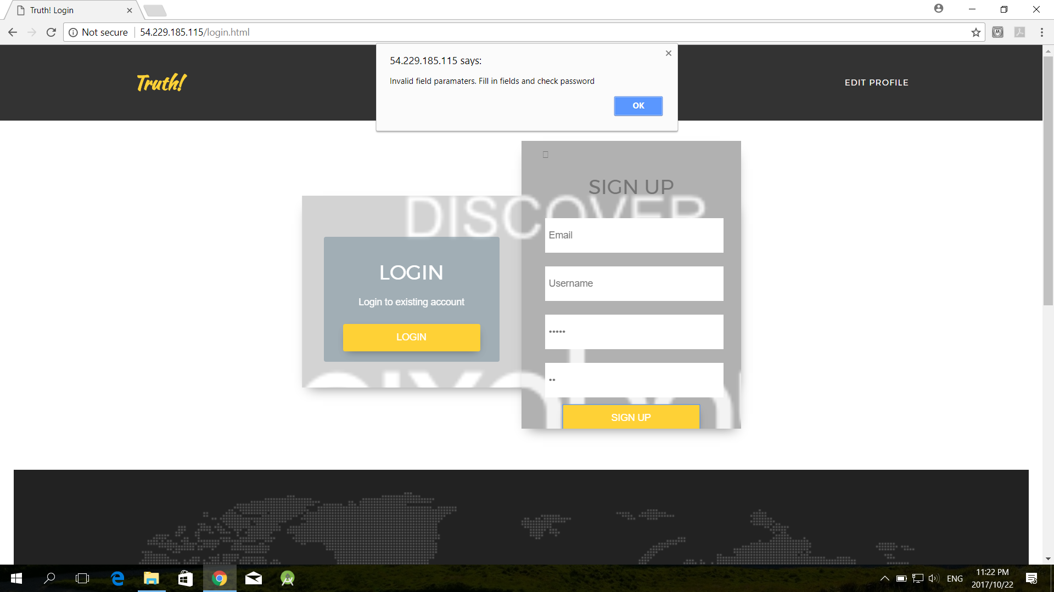

Once a user is successfully created the user is redirected to the home page:

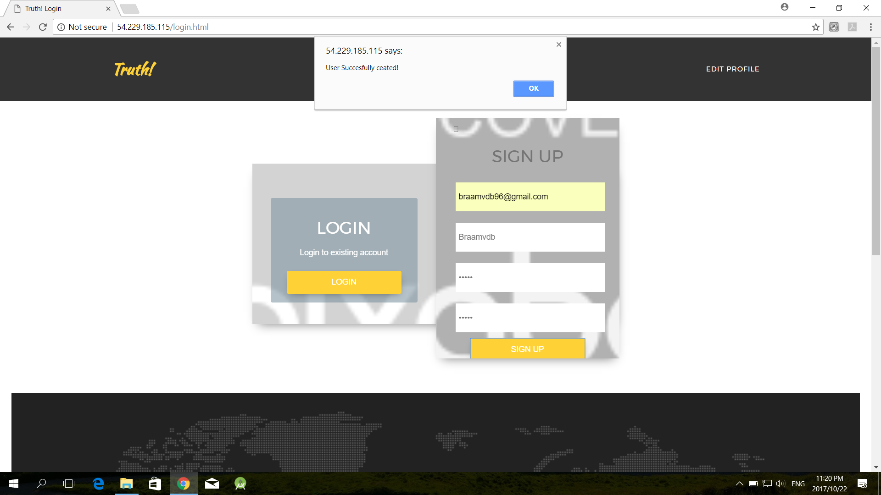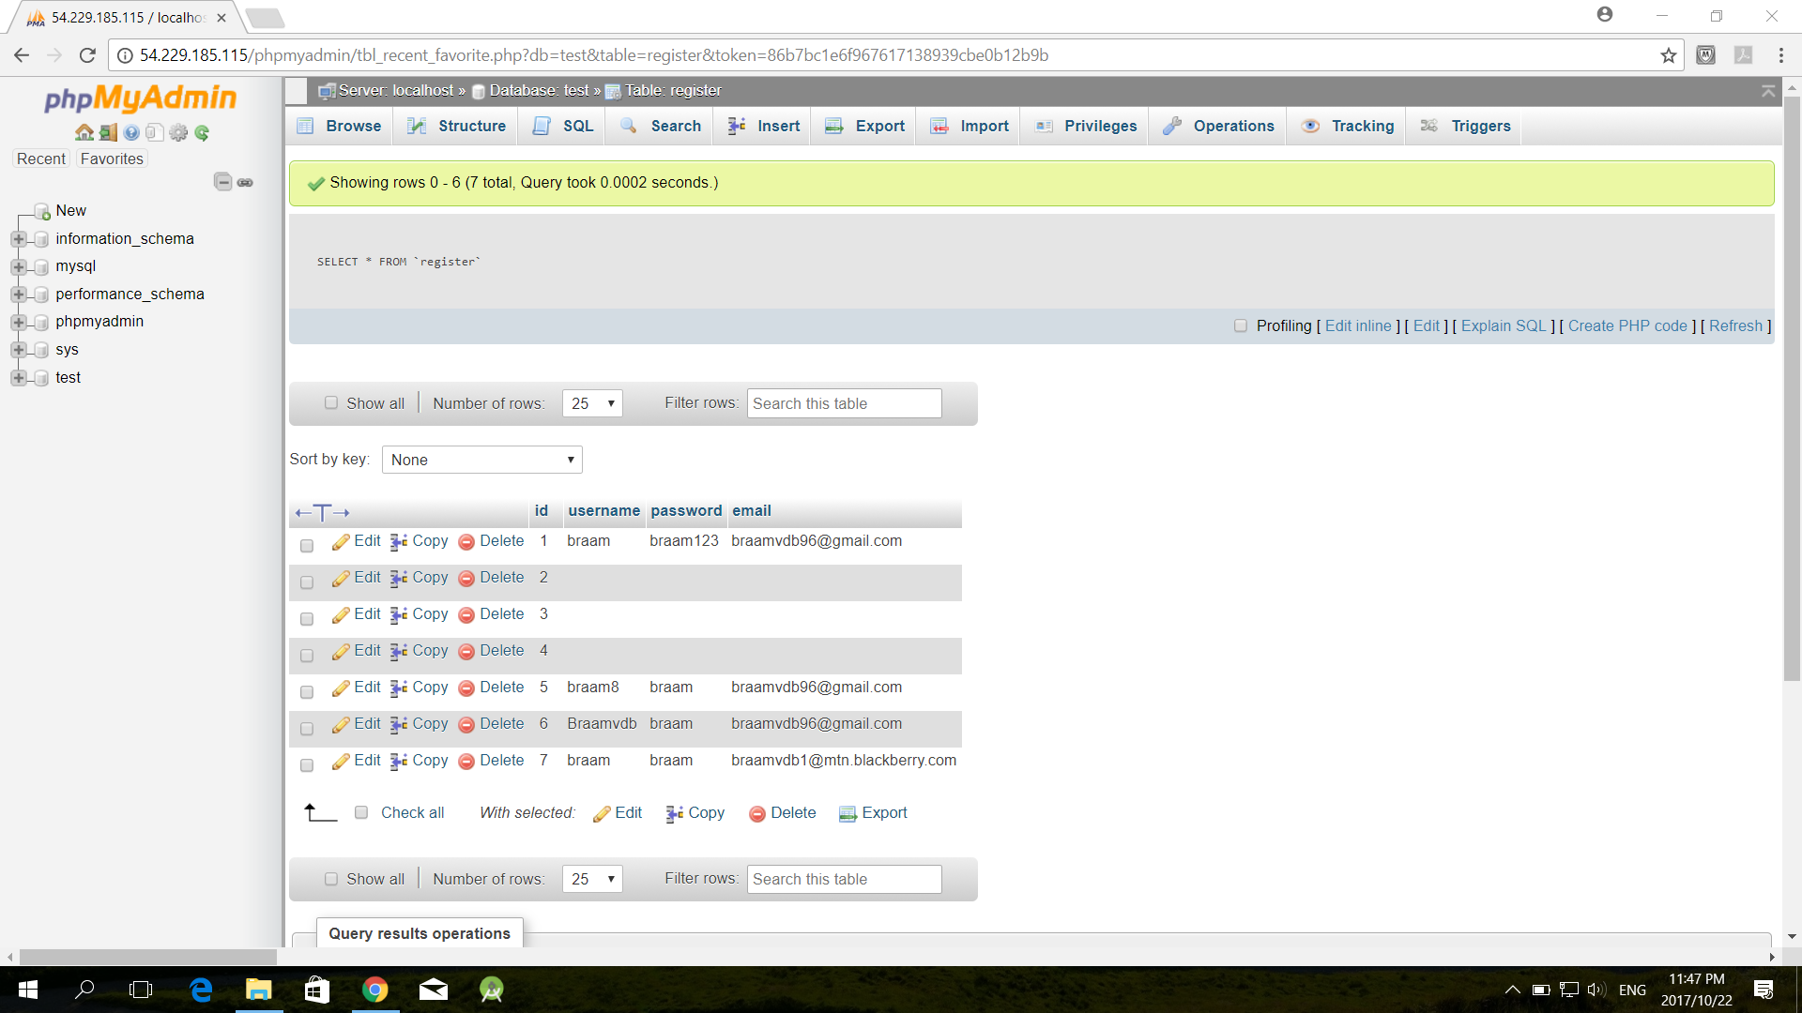



Login

When a user exits, and has already been registered, and wants to log in he can do so using the username and password created in register:

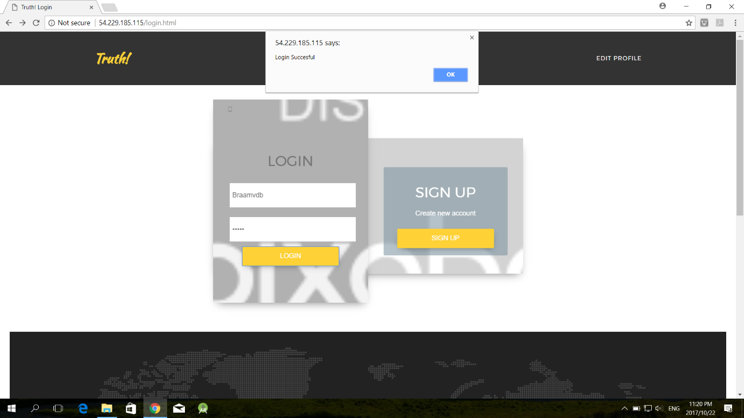

When a user is successfully logged in he is redirected to the home page. When the log in fails he is redirected to the login page to try and log in again:

When the Admin user logs in with the given credentials he is redirected to the Create Article page for admin users.

